SOLANO COMMUNITY COLLEGE
MT 164, PROGRAMMABLE LOGIC CONTROLLERS
Spring, 2018

PLC PROGRAMMING LAB 2
Catharine Crayne
02/19/2018

OBJECTIVE
- To write a PLC Program that uses safety disconnect switch in a NC configuration.
- To learn how to create latching outputs in various configurations.
- To learn how to utilize the Data File I/O table.

GROUP MEMBERS

MATERIALS & EQUIPMENT
Micrologix 1100 Trainer Unit, wires, RSLinx and RSLogix software, laptop, crossover cable.

PROCEDURE:
- Wire up a push-button switch, disconnect safety switch, and 2 lights to the PLC and the distribution blocks on the trainer. Use the diagrams as a guide.

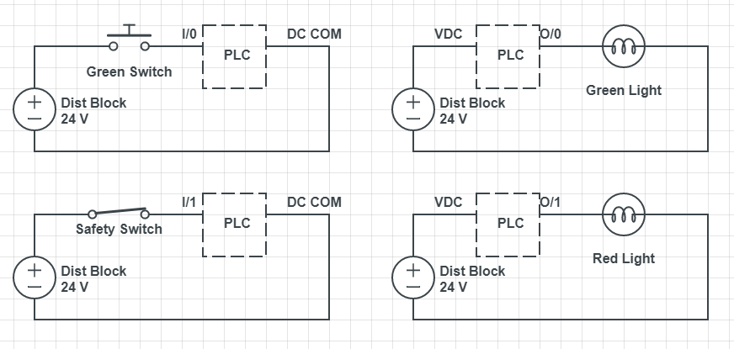
- Write a simple ladder logic program that uses a green switch to turn on a green light so that it stays on after you let go of the switch (Use a Latching Output). Use the safety disconnect switch to unlatch it and turn off that green light while then turning on a red light.
- Plug in the PLC Trainer and download that program into the Micrologix PLC.
- Verify the program works. Save it or screenshot it to use in your lab write up.
- Examine the Data File for the Inputs and Outputs while you are running the program.
- Now change the program so that it still works the same but don’t use the Output Latch. Save or screenshot this.
- Download that program and verify that it works.
- Next “loosen” the wire to the NC safety switch so that you can pull it out while it is running. Power the PLC Trainer ON. Run the same program as before. Pull the loose wire out, being careful not to make contact with any other metal, component, or yourself. What happens to the status of the lights? Unplug the trainer.
- Now “loosely” connect that wire to the safety switch to the N.O. position and update your program to reflect that change from NC to NO. Download that program and verify it works.
- Press the Green Button to energize the green light.
- Then pull the “loose” wire out of the safety switch, again being careful not to make contact with any other metal, component, or yourself. What do you observe about the Green & Red Lights? Unplug the Trainer.
- Reattach that loose wire to the NO Safety switch. Plug the PLC Trainer back in.
- Examine the program below. Predict how it will behave.
- 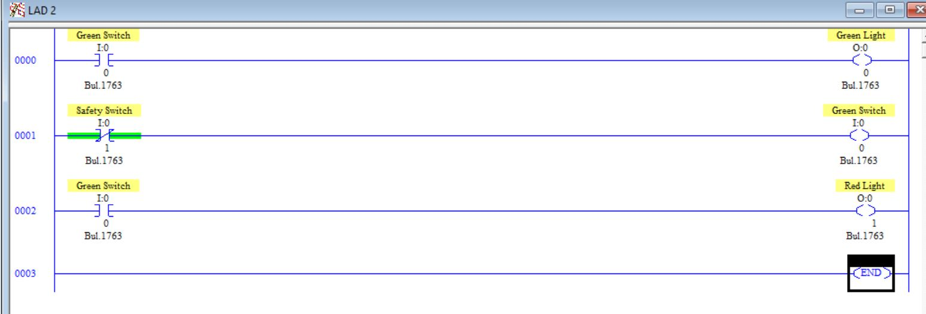
- Write the program and Download it. Describe what happens and explain why.

RESULTS - DATA
Step 2: Snapshot of our program.

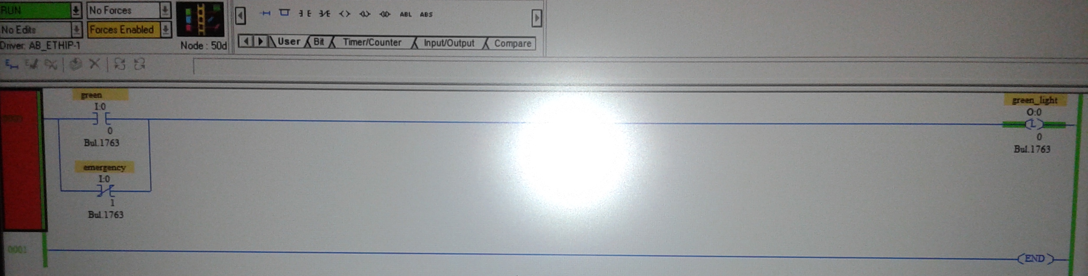

Step 6 & 9: Snapshot of our program.
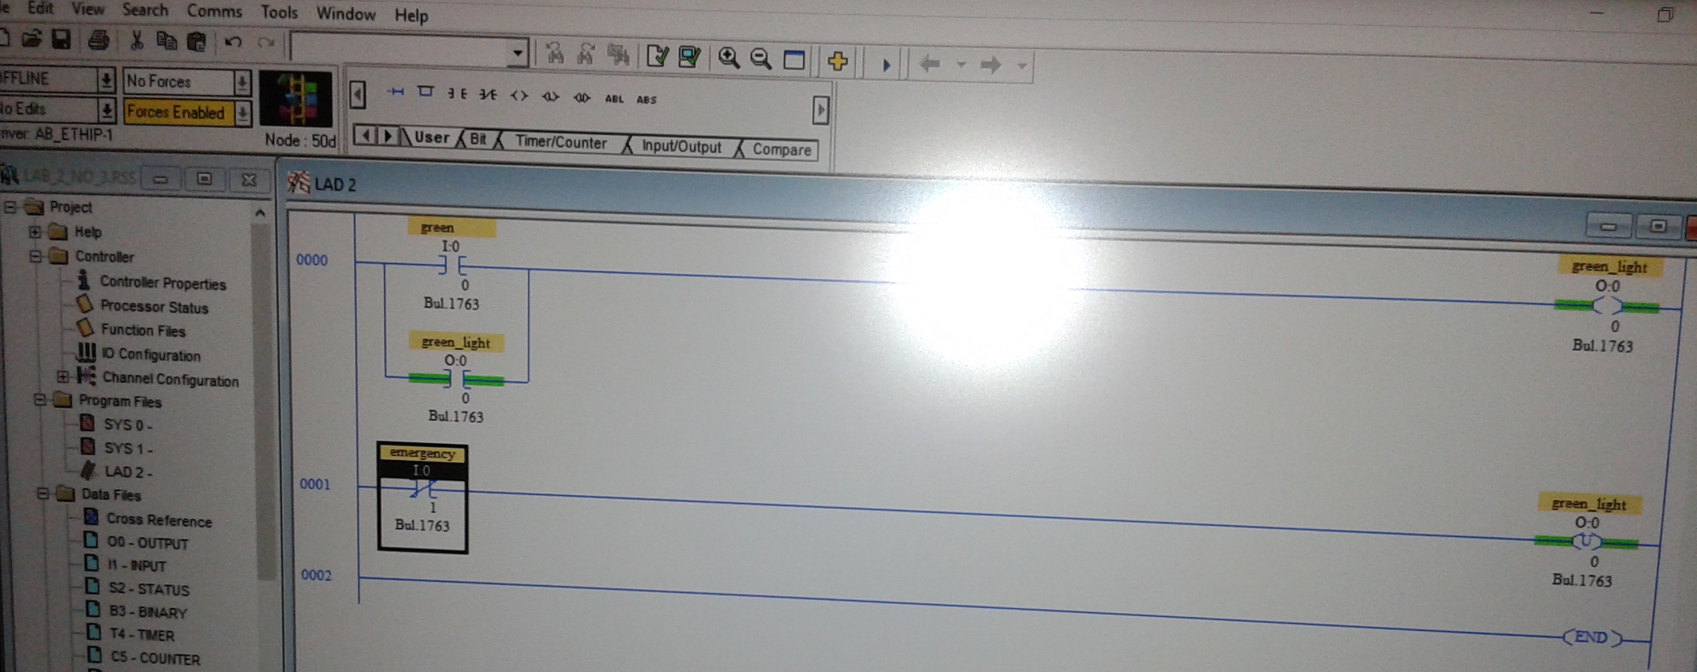

OBSERVATIONS
Step 1: Picture of our setup
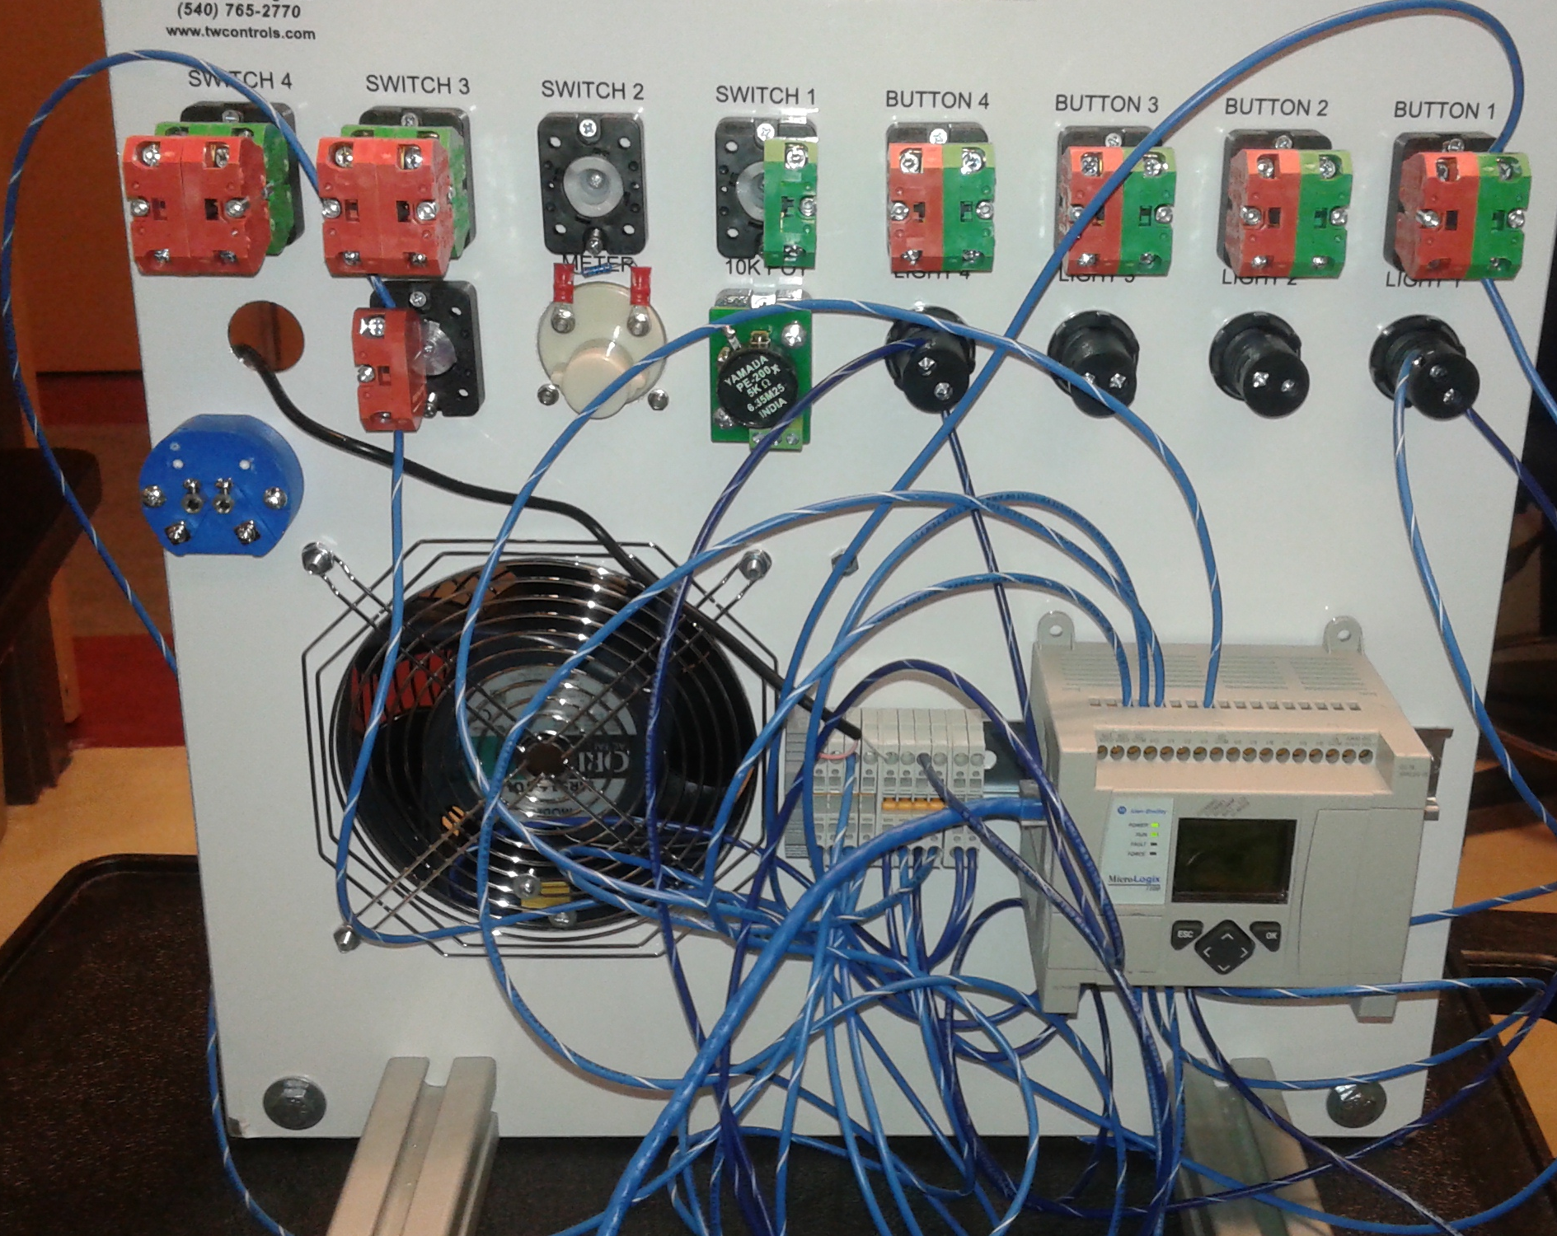

Step 4: Picture of our setup
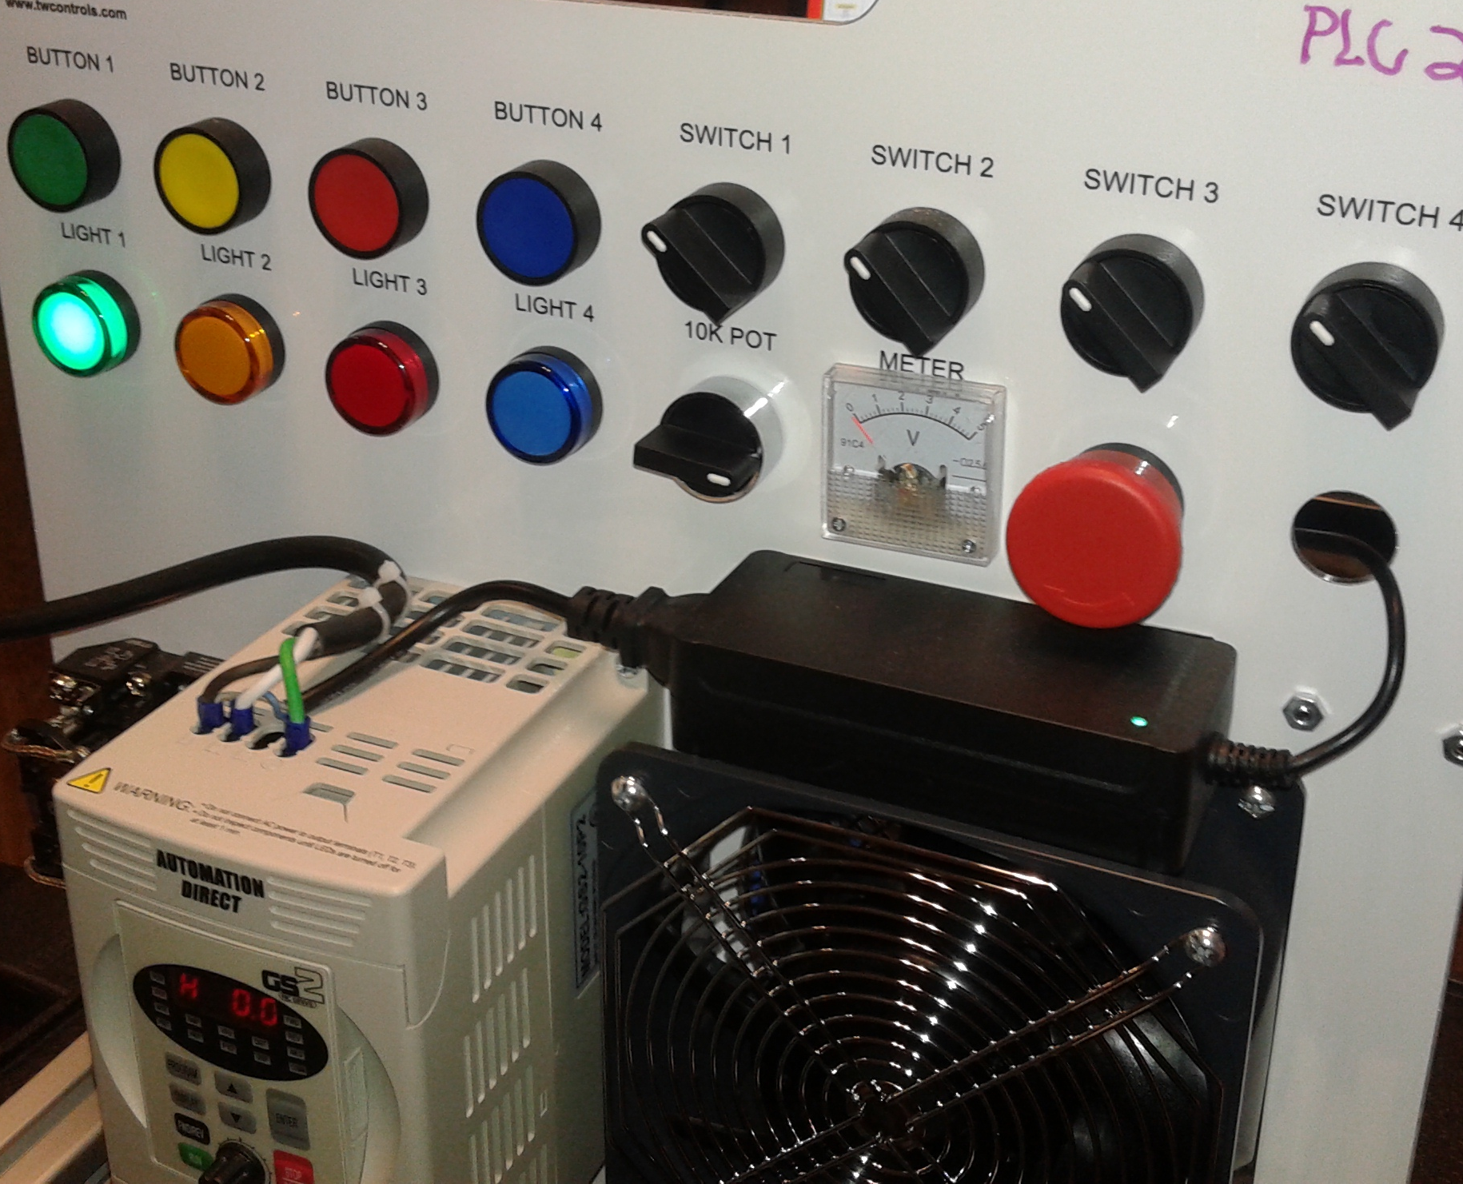

Other Notes:
In this lab we did not get all the way through the steps due to the fault code in the PLC. At that point we had not gone over how to diagnose/clear the fault code and resume programming/operation.

ANALYSIS QUESTIONS:
- What is the inherent dangers of using Output Latch commands?
The output latch maintains the current flow, and additional safety measures must be built into the hardware or program configuration.
- Why are NC switches the safer approach when using disconnects, limits, etc..?
Using a NC switch prevents the flow of electricity unless the user or program purposefully energizes the circuit by closing the switch.
- Describe the scan cycle of a PLC and when the inputs and outputs are dealt with. How does this apply to the last program in step 15?
- First, the switches and inputs are examined and their status is recorded in the controllers memory.
- A closed contact is recorded in memory as logic 1 and an open contact as logic 0.
- Next, the ladder diagram is evaluated, with each internal contact given an OPEN or CLOSED status according to its recorded 1 or 0 state.
- When the states of the input contacts provide logic continuity from left to right across the rund, the output memory location is given a logic value (1 or 0) and the output module interface contacts will 0 close.
- When there is no logic continuity of the program rung, the output memory location is set to logic 0 and the output module interface contacts will be open.

In Step 15, the green switch is given the logic value of 1 when closed, and if it is closed, the output light energizes and is also given a value of 1. The next rung of the ladder logic program is evaluated, and if the NO emergency switch is open, it is assigned a value of zero and the green output switch is assigned a value of zero and switched to the OFF position. If the NO emergency switch is closed, it is assigned a value of one, as is the green output switch. The next ladder rung is evaluated and the green switch is assigned the value of 1 (carried over from the previous ladder rung), and the red light is assigned a value of 1 (ON).

